Privacy Patrol

Privacy Patrol

Activity Overview
Students explain that they have the right to control what they share with AI and understand the importance of making thoughtful choices about their personal information.
Learning Objective  Students analyze what types of information AI systems might ask for and evaluate whether it is safe, necessary, or appropriate to share. | Standards & Competencies  - 1a (Recognize AI Systems)  - 2b (Examine AI use and outputs)  - CCSS.ELA.SL.4.1: Engage effectively in collaborative discussions
Materials  - Information Cards  - Class poster with Fair AI Guidelines | Preparation  - Print a set of Information Cards and Sorting Mats for each group.  - Display Fair AI Guidelines poster.

Launch (2-3 minutes)
Slide | Exploration Guide
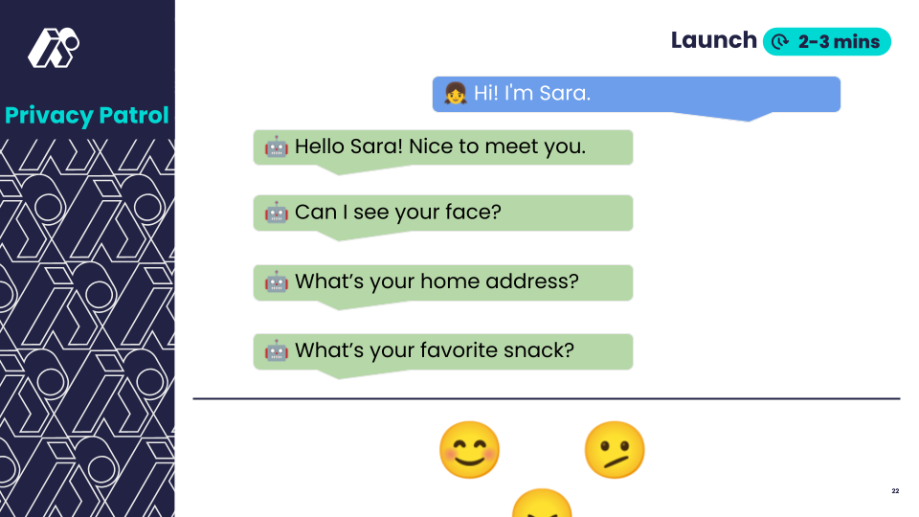 | Say: “Imagine you just opened an app, and it asks you these three questions. You didn’t expect it, and it didn’t tell you why it needs this information.”  Ask:  - “How do these questions make you feel?”  - “Which would you answer? Which would you skip?”  - “What would you want to know before answering?”  Look For:  - "Why does the app want my address?"  - "I’d share my favorite snack, but not my face."  - "It depends on who’s asking and what it’s for.”  Common Student Misconceptions:  - "If an AI asks for something, it must be safe to share."  - Response: "AI can remember and use your data to make decisions. Some companies sell data to advertisers."
💡Teaching Tip: Pre-teach vocabulary like "private information" and "permission" using examples and visuals.

Play (8-12 minutes)
Slide | Exploration Guide
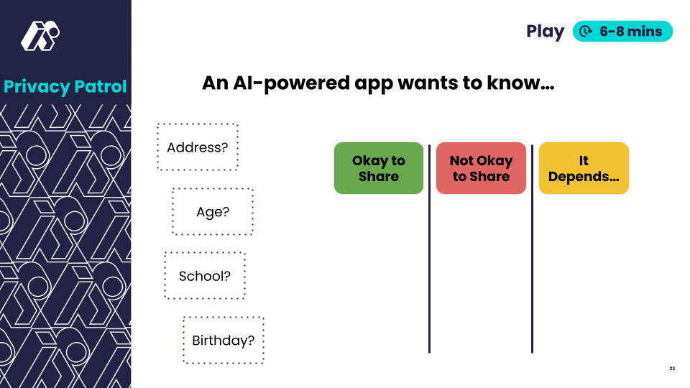 | Say: “Now, you’ll work in teams to sort things AI might ask for. You’ll decide what is okay to share, not okay to share, or when it depends.”  Distribute information cards. In small groups, students sort cards into categories.  As students sort, ask:  - “Why is this okay or not okay?”  - “What would make you feel safer about sharing this?”  Look For:  - “This isn’t private, but I still want to know why they need it.”  - “I’d share this if I knew it wasn’t going to be saved.”  - “I don’t mind sharing this, but I’d ask my grown-up first.”  Common Student Misconceptions:  - "AI won’t do anything bad with my data."  - Response: "AI can use or share your data in ways you don’t expect. We need to think before we share."
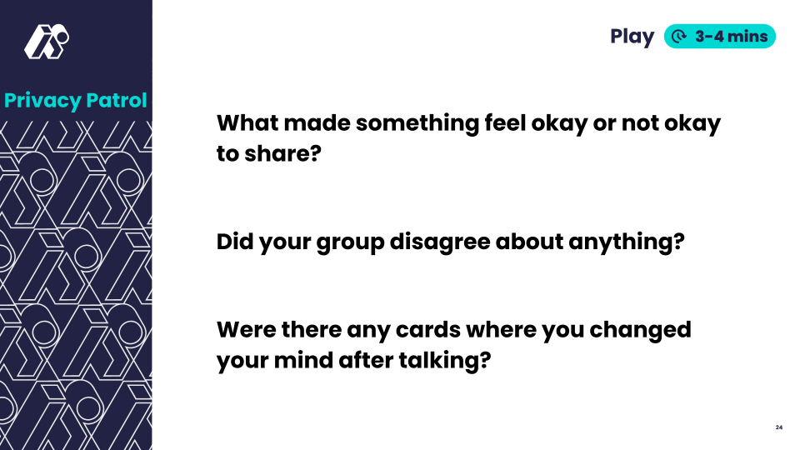 | Say: “Let’s think about the decisions you just made. You were in charge of your own information. That’s a big deal!”  Ask:  - “What made something feel okay or not okay to share?”  - “Did your group disagree about anything?”  - “Were there any cards where you changed your mind after talking?”  In pairs or small groups, students discuss, then share whole group.  Look For:  - “Some things felt more private, and I wanted to know why AI needed them.”  - “We should stop and think before we click share.”  - “We should only share what we’re okay with others seeing.”  Common Student Misconceptions:  - "AI systems make their own decisions about privacy"  - Response: Clarify that humans program AI privacy rules
💡Teaching Tip: Provide a sorting mat for students to physically sort information cards. Provide sentence starters:
- "I felt okay sharing ______ because ______."
- "I didn’t want to share ______ because ______."

Land (3-5 minutes)
Slide | Exploration Guide
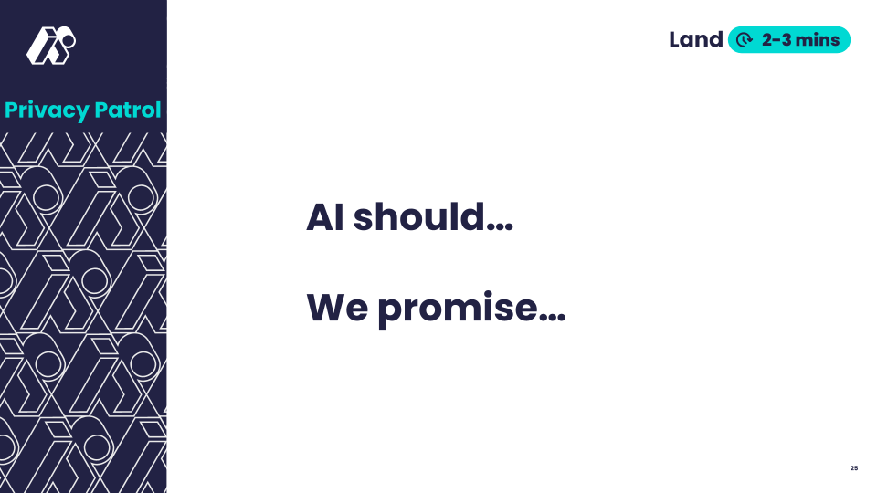 | Say: “Let’s turn everything we learned today into a belief about fair AI—something we can all agree on. What should be true about AI using your info? What’s something you’ll remember before you share with AI?”  Students brainstorm statements in partners or small groups. Students propose wording for Fair AI guideline statement. Record statements with students OR show the next slide.  Look For:  - “AI should always ask permission before using people’s information.”  - “We should think carefully before sharing information.”  Common Student Misconceptions:  - "AI systems make their own decisions about privacy"  - Response: Clarify that humans program AI privacy rules
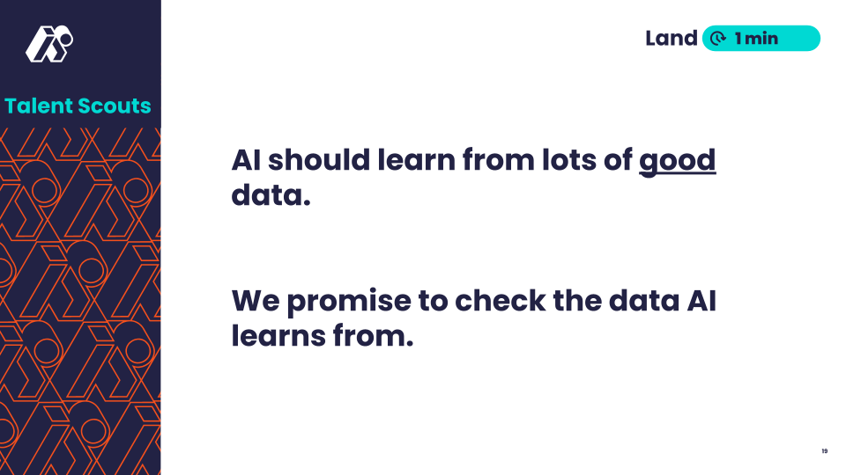 | Share this slide or the written version of the statements agreed upon by the class.  Say: "Here's one way we could phrase our learning. Does this capture our ideas, or do you prefer your wording?
💡Teaching Tip: Encourage students to use their own words - there is no single "right" answer. Provide sentence starters:
- "AI should ______ because ______."
- "Before I share with AI, I will ______."

